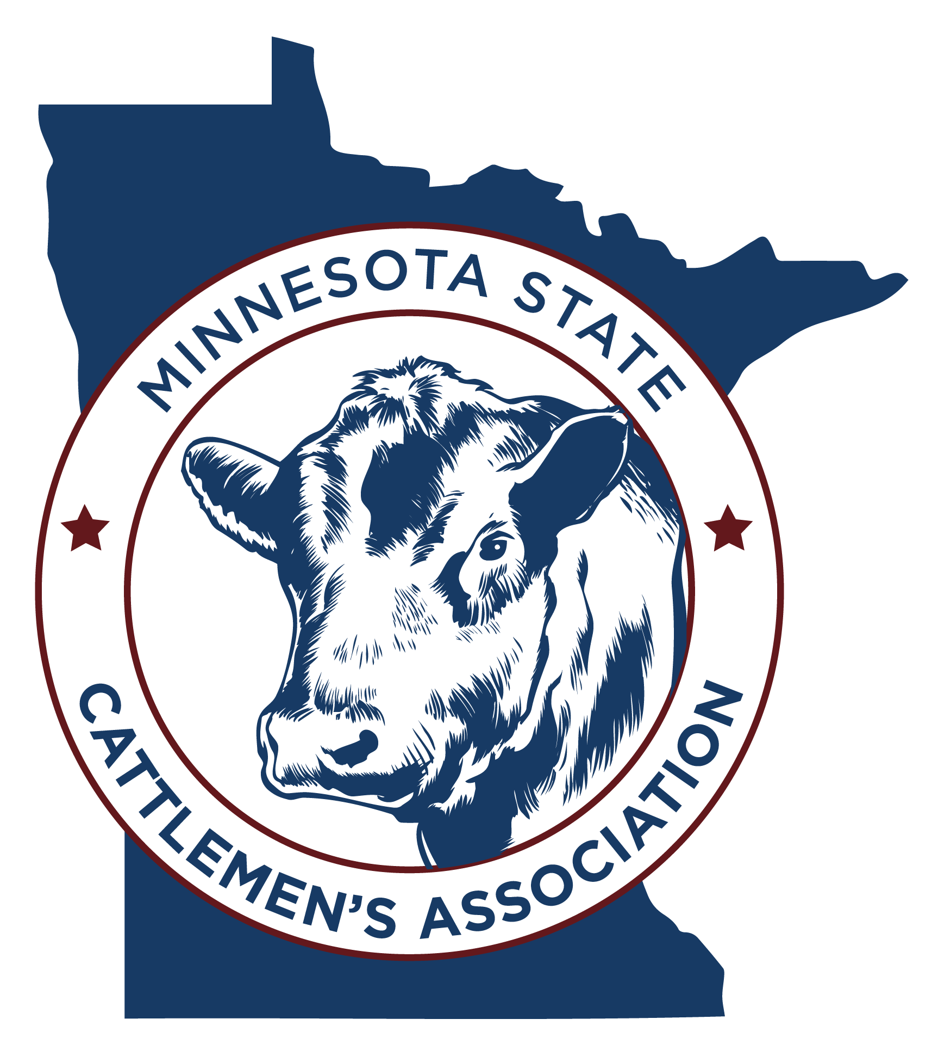

2023 Minnesota Cattle Industry Convention

December 15 & 16, 2023

Arrowwood Resort

Alexandria, MN

Greetings!

The Minnesota State Cattlemen’s Association is excited to announce the Minnesota Cattle Industry Convention is in Alexandria for 2023! We would like to invite you once again to meet our members and promote your business or organization at our annual convention.

There are many exciting ways for you to display and promote your business or organization at the 2023 MSCA convention.

- Display or Exhibit Booth – This a great way to get face to face contact with convention goers. Our attendees are the decision makers on their farm or ranch!
- General Sponsorship – Your business or organization name will be listed on signage during the entire convention and trade show thanking you for your support.
- Trade Show Break Sponsorship – Your business or organization name will be listed on signage during the event, and food items will be placed in or near your exhibit booth.
- Educational Session Sponsorship – Your business or organization’s name will be listed on signage near the entrance of the educational session in which you sponsor, and a representative from your organization will be invited to introduce themselves and the speaker.
- Meal/Speaker Sponsorship – Your business or organization will be listed on signage during the event and will be provided time to introduce yourself and provide comments to the audience.
- Entertainment Sponsorship – Your business or organization will be listed as a sponsor with signage on stage during the event and recognition as a sponsor prior to the event.
- President’s Social Sponsorship – Your business or organization will be listed on signage during the President’s Social prior to the Best of Beef Banquet.
- Hospitality Room Sponsorship – Your business or organization will be listed on signage in the Hospitality Room Thursday night where MSCA members and convention sponsors network, and Friday night during a fun social gathering.

ADDITIONAL ADVERTISEMENT OPPORTUNITY! If you have a product or service special/promotion that you'd like to feature at the 2023 Minnesota Cattle Industry Convention in your trade show booth or a giveaway you’d like highlighted, send us an ad or description of that product or service and we'll feature it in the November Minnesota Cattleman newspaper AND in the 2023 Minnesota Cattle Industry Convention catalog.

We would like to express our continued gratitude for your support of Minnesota’s beef cattle industry. As a small token of our appreciation, we invite all exhibitors and sponsors to attend a special appreciation social on the evening of Thursday, December 14, 2023 with MSCA members and guests. This will be held in our hospitality rooms at the Arrowwood Resort in Alexandria.

See the enclosed documents for more detailed information about the sponsorship opportunities listed above. Please feel free to call me at 507-360-7937 or email mnscamembership@gmail.com if you have any questions!

Kindest Regards,

Angie Ford

Chair of Membership and Industry Relations

Location & Room Reservations

Arrowwood Resort, Alexandria, MN

866-386-5263

$139 Standard Rooms – Single, Double, Triple and Quad Rooms

$169 Upgraded Rooms – Single, Double, Triple and Quad Rooms

$199 Suites – Single, Double, Triple and Quad Rooms

The room block will be reserved until 11/17/23, so be sure to reserve your room before then.

For Reservations:

When making reservations, please mention Minnesota Cattle Industry Convention and Trade Show. Please use the group name MN State Cattlemen.

Exhibitor Information
- The price to exhibit is $500 for a standard 8'-10' booth.
- One individual complementary registration is included with the booth cost (please list their name when

you register). If you plan on having additional people attend, they will need to register separately.
- If you need a bigger space or have any special requests, contact Angie Ford at 507-360-7937.
- Electricity is included with booth fee, please note if you would like electricity.
- Tradeshow set up is from 8-10:30 a.m. Friday.
- Dedicated tradeshow time on Friday afternoon and Saturday morning.
  - Trade show opens at 10:30 a.m. Friday and 9 a.m. Saturday.

Sponsor Information

General Sponsorship ($250) – Sponsorship helps cover advertising, venue costs and convention materials. Your business or organization name will be listed on signage during the entire convention, in the convention materials and trade show thanking you for your support.

Trade Show Break Sponsorship ($300)

Your business or organization name will be listed on signage during the event, in the convention materials and food items can be placed near your exhibit booth.
- Friday afternoon and Saturday mid-morning

Educational Session Sponsorship ($450) – Sponsorship helps cover speaking fees, travel & lodging.

Your business or organization will be listed on signage during the event, and you will be provided time to introduce yourself and provide comments to the audience.

President’s Social Sponsorship ($500) – Your business or organization will be listed on signage during the President’s Social prior to the Best of Beef Banquet.

Meal/Speaker Sponsorship ($500) – Sponsorship helps cover meal costs, speaking fees, travel & lodging. Your business or organization will be listed on signage during the meal.

Hospitality Room Sponsorship ($250) – Sponsorship helps cover meal and drink costs, as well as room rental cost. Your business or organization will be listed on signage during the social event on Thursday and Friday night.

Entertainment Sponsorship ($1,000) – Your business or organization will be listed as a sponsor with signage on stage during the event and recognition as a sponsor prior to the event.

Registration for Sponsors: Deadline October 23rd for listing in the November Convention issue of the Minnesota Cattleman Newspaper.

2023 Minnesota Cattle Industry Conference Sponsorship

Online registration available at mnsca.org

Sponsor Contact Name _____________________________Business_________________________________

Address______________________________City _______________________ State _____Zip______________

Email _________________________ Phone_________________________________

Meeting and Tradeshow Registration: | Number Desired | Fee | Total
Exhibit Booth |  | X $500.00 | =
General Sponsorship |  | X $250.00 | =
Trade Show Break Sponsorship |  | X $300.00 | =
Educational Session Sponsorship  (Specify specific speaker_______________________) |  | X $450.00 | =
Meal/Speaker Sponsorship |  | X $500.00 | =
Entertainment General Sponsorship  President’s Social Sponsorship  Hospitality Room Sponsorship |  | X$1,000.00  X $500.00  X $250.00 | =  =  =
Full Registration Fee (Both Days, Per Person) |  | X $75.00 | =
One Day Registration Fee (Per Person)  Check Day: Friday_______ Saturday _________ |  | X $60.00 | =
Total |  |  | =

Attendee First Name: | Last Name: | Attending Thurs Night Social?

Payment Information:

Payment Method: 􀂅 Check Enclosed (“MSCA Convention”) 􀂅 Credit Card

Credit Card: __ MC __Visa __ Discover Credit Card Number _____________________ Billing Zip Code____________

Name on Credit Card (Exactly as listed) _________________________________________________________

Authorizing Signature _______________________________________________________________

Expiration Date_________________ CVV Code __________________Today’s Date_________________

Please return completed form to:

Internal Use Only.

Date Received: _______________________

Payment Method/Chk #:________________

Amount Received: ____________________

Booth Assigned: ______________________

Member/Beef Alliance?: ________________

Minnesota State Cattlemen’s Association

PO Box 12

Maple Plain, MN 55359

